ASSIGNMENT 1- Stage 2: Implementing CSS. Semester 1, 2021

Instructions

This stage will help you to “dress up” the webpage you created in stage 1 using CSS. Once again, here you’ll find a case study, as an example only, to get an idea about what it is expected to complete by the due date. The case study DOES NOT HAVE every element included in the marking criteria. The aim is you to improve the webpage developed in the first stage using your own topic, but including ALL CSS approaches: embedded, inline, and external.

You are to demonstrate your understanding of the correct use of CSS styling, configure background and text colour on web pages, create style sheets that configure common colour and text properties, apply inline styles, use embedded style sheets, use external style sheets, configure element and class selectors, utilize the “cascade” in CSS, and validate CSS. In addition, your website MUST INCLUDE at least FIVE PAGES (including the main page). All of them linked by a <nav> menu.

The map of your website as well as references are both important. You must include the map of your website according to the lectures of week 3. Similarly, you need to submit a word document with all the references you have come across so far. Validation is still important. See “The W3C CSS Validation Service” to get this task done. The submission of a screenshot of the validation is enough for marking purposes.

Part II of this document has a sample case study that we’ll go through during the tutorial. Following the approach of the first stage, you will need to follow the same steps of the case study but using your own topic.

A sample case study using CSS

This is your opportunity to compile everything you have learnt so far. Please, follow your lecturer’s guidelines when creating this simple webpage, as you will be undertaking the same steps to create your own.

Following the Fish Creek Animal Clinic Case Study of the previous stage. Figure below shows a site map for the Fish Creek website.

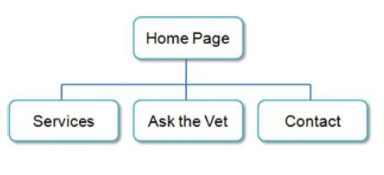

The Home page and Services page were created previously. You will develop a new version that uses an external style sheet to configure text and colour. Figure below depicts the wireframe page layout.

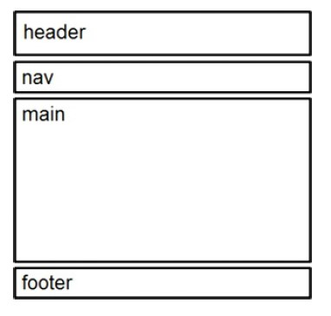
Wireframes are diagrams (layouts) of a page that indicate how the structure of a web page could be configured with the header, nav, main, div, and footer elements.

You have the following tasks:

- Create a new folder for this Fish Creek case study.
- Create an external style sheet named fishcreek.css that configures the colour and text for the Fish Creek website.
- Modify the Home page to utilize an external style sheet to configure colours and fonts. The new Home page and colour swatches are shown in the following figure:

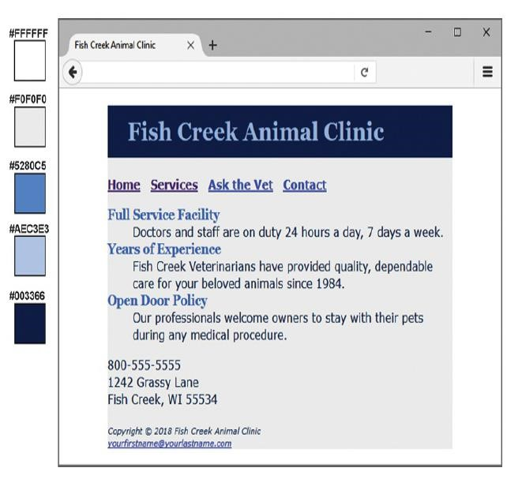

- Modify the Services page to be consistent with the new Home page.
- Configure centred page layout.

Hands-On Practice Case Study

Task 1: The Website Folder.

- Create a folder on your hard drive or portable storage device called fishcreekcss.
- Copy all the files from your previous week’s fishcreek folder into the fishcreekcss folder.

Task 2: The External Style Sheet.

You will use a text editor to create an external style sheet named fishcreek.css. Code the CSS to configure the following:

- Global styles for the document (use the body element selector) with background colour #FFFFFF; text colour #003366; and Verdana, Arial, or any sans-serif font.
- Styles for the header element selector that configure background colour #003366, text colour #AEC3E3, and a serif font such as Georgia or Times New Roman.
- Styles for the h1 element selector that configure 200% line height and set the text-indent property to 1em.
- Styles for the nav element selector that display text in bold.
- Styles for the dt element selector that configure #5280C5 text colour, size 1.1em font in bold, and a serif font such as Georgia or Times New Roman.
- Styles for a class named category with bold font, text colour #5380C5, and a serif font such as Georgia or Times New Roman.
- Styles for the footer element selector with a small font size (.70em) and italic text.
- Save the file as fishcreek.css in the fishcreekcss folder. Check your syntax with the CSS validator (http://jigsaw.w3.org/css-validator).
- Correct and retest if necessary.

Task 3: The Home Page.

Launch a text editor and open the index.html file. You will modify this file to apply styles from the fishcreek.css external style sheet as follows:

- Add a <link> element to associate the web page with the fishcreek.css external style sheet file.
- Configure the navigation area. Remove the <b> element from the navigation area, because the CSS will configure the bold font style.
- Configure the content area. Remove the <strong> tags from within each dt element, because the CSS will configure the bold font style.
- Configure the page footer area. Remove the <small> and <i> elements—they are no longer needed since CSS is now used to configure the text.

Save the index.html file, and test in a browser.

Task 4: The Services Page.

Launch a text editor and open the services.html file. You will modify this file in a similar manner:

- Add the <link> element, configure the navigation area and page footer areas, configure the category classes (Hint: Use the <span> element to contain the name of each service offered), and remove the strong tags.)
- Save and test your new services.html page.

Task 5: Center Page Layout with CSS.

Modify fishcreek.css, index.html, and services.html to configure page content that is centred with 80% width with a light grey background colour.

- Launch a text editor and open the fishcreek.css file.
- Add a style rule for an id named wrapper with width set to 80%, margin-right set to auto, margin-left set to auto, and background colour set to #F0F0F0.
- Launch a text editor and open the index.html file. Add the HTML code to configure a div element assigned to the id wrapper that “wraps”, or contains, the code within the body section. Save and test your index.html page in a browser and you will notice that the page content is now centred within the browser viewport.
- Launch a text editor and open the services.html file. Add the HTML code to configure a div element assigned to the id wrapper that “wraps”, or contains, the code within the body section. Save and test your services.html page in a browser and you will notice that the page content is now centred within the browser viewport as shown in Figure below.

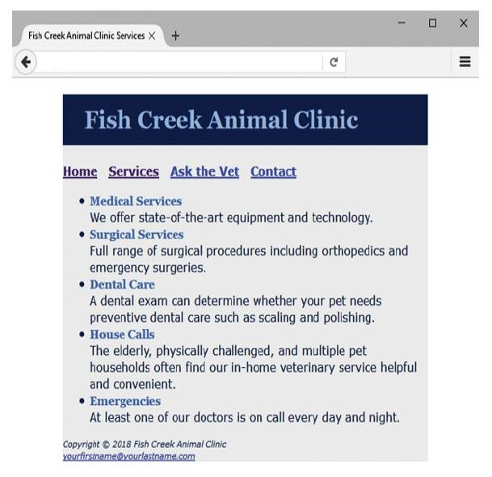
Experiment with modifying the fishcreek.css file. Change the page background colour, the font family, and so on. Test your pages in a browser. Isn’t amazing how a change in a single file can affect multiple files when external style sheets are used?

